

G2

SCHOOL OF COMPUTER SCIENCE AND ENGINEERING
Continuous Assessment Test – II Key
Course Name & Code: Data Structure and Algorithms CSE 2003
Class Number: Slot:G2 Exam Duration: 90 Min Maximum Marks:50

Answer All Questions

1.a) Construct an unique binary tree whose preorder traversal is and in order
traversal is [CO 5] (5M)

Solution
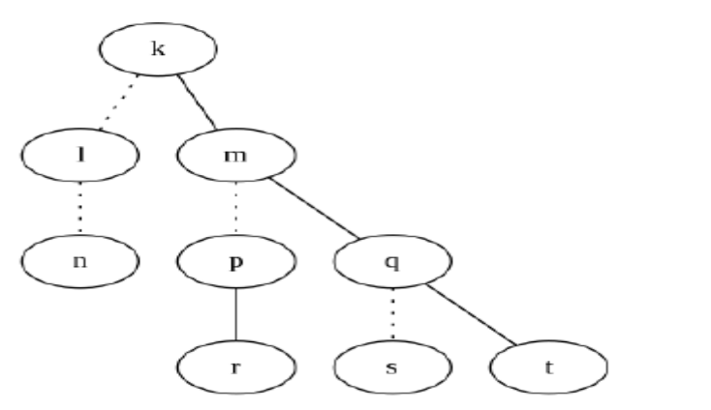
b) Construct a binary tree from the following general tree. [CO 5] (5 M)

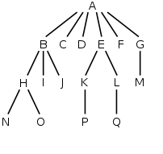
Solution

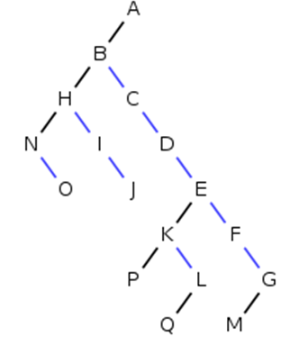

2) Consider a hashing mechanism which accepts integer keys, k, of maximum five digits, calculates the hash table size, p, as the minimum prime number which is larger than the number of keys entered (for eg., if the number of entries are 5, the hash table size p is 7). The hashing function takes the sum of the squares of the second, third and fourth digits, sum1, applies modular p operation, resulting in the value x. Thus the key k gets stored in x location of the hash table. If it is already occupied, then sum2 is calculated from the key by computing the sum of the squares of the first and fifth digits, applies modular p operation, resulting in the value y. Thus the key is placed y locations away from its intended location. If collision occurs for the second time, displacement (from original x location) should be |x-y|. For third time, the displacement should be |2x-y|, and so on.

If the key has less than five digits, then appropriate zero padding is required to compute x and y. Compare the performance (in terms of no. of collisions) of this technique with general modular function and linear probing.
The numbers are 12345, 25378, 2543, 71356, 99929, 23151, 131, 4217. [CO 3] (10 M)

Solution:

The hash table size, p, has to be of size 11.

The number of collisions in first method 3 (including a double collision for 131)
The number of collisions in second method 1

Values from Question. | Index | Results for proposed method 1 | Results for proposed method 2
12345 | 0 | 2543 | 131
25378 | 1 |  | 25378
2543 | 2 | 99929 | 2543
71356 | 3 | 71356 | 12345
99929 | 4 | 23151 | 4217
23151 | 5 | 12345 | 99929
131 | 6 | 4217
4217 | 7 |  | 23151
 | 8
 | 9 | 25378
 | 10 | 131 | 71356

3) Show the result of inserting the following elements one at a time sachin, akil, aravind, kumar,
ravi, vijay, namit, mukesh, javed, vikram into an initially empty binary heap. [CO 3] (10 M)
Solution: Use Ascii Key Value for Names.
Inserting each elements ( 1 Mark)

4) a) You are given a linked list, L, and another linked list, P, containing integers, sorted in
ascending order. The operation print_lots(L,P) will print the elements in L that are in positions
specified by P. For instance, if P = 1, 3, 4, 6, the first, third, fourth, and sixth elements in L are
printed. Write the routine for print_lots(L,P). [CO 3] (5 M)

void
PrintLots( List L, List P )
{
int Counter;
Position Lpos, Ppos;
Lpos = First( L );
Ppos = First( P );
Counter = 1;
while( Lpos != NULL && Ppos != NULL )
{
if( Ppos->Element == Counter++ )
{
printf( "%? ", Lpos->Element );
Ppos = Next( Ppos, P );
}
Lpos = Next( Lpos, L );
}
}

b) For the graph given below, write a path from vertex A to vertex I using (5 M)
(i) DFS and (ii) BFS. What is your inference? [CO 4]
A
B
C
E
F
G
H
I
J
6
2
2
8
1
2
1
3
1
2
1
5

Solution:
BFS : A E H I (2.5 Marks)
DFS : ABEFHI (2.5 Marks)

5) For the given weighted graph G=(V,E), [CO 4]

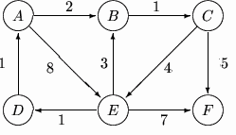
(a) Output the sequence of vertices identified by the Dijkstra’s algorithm for single source
shortest path when the algorithm is started at node A. [4]

Solution: ABCEDF
(b) Write down the sequence of vertices in the shortest path from A to E. [3]
Solution: ABCE
(c) What is the cost of shortest path from A to F? [3]
Solution : 8

